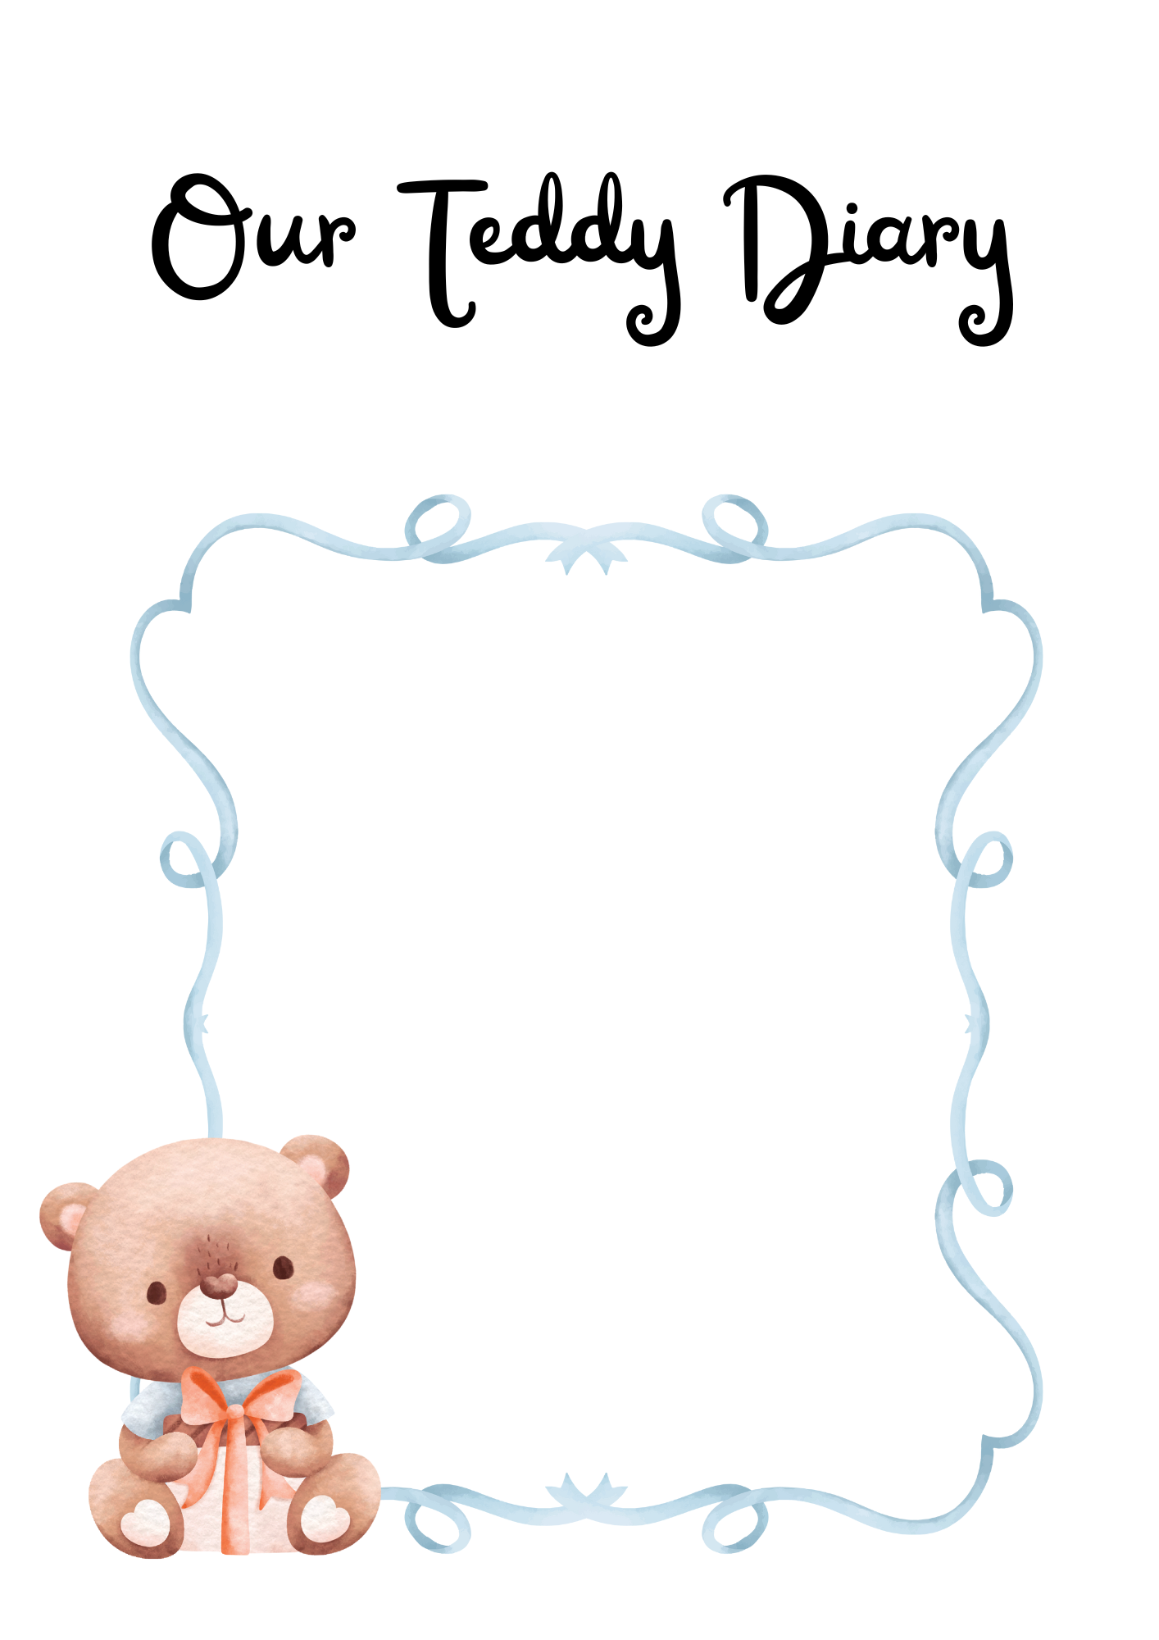

*Dear Parents/Guardians,*

*Welcome to Ted’s Diary. Ted is our class mascot!   
He is a cuddly, friendly guy who loves to go on adventures.*

*When your child has Ted at home for his visit, please include him in all family activities. He loves to sit at the table at mealtimes, play games, make things and explore and play outside.*

*At the end of Ted’s time with your family, please help your child to write/draw about his/her time with Ted on the sheets provided with this scrapbook. You can stick in a photo or drawing of your adventure if you wish!*

*Thank you for supporting us with this   
collaborative class project.*